Networks Analysis Summative

Kmgj58

Question 1:

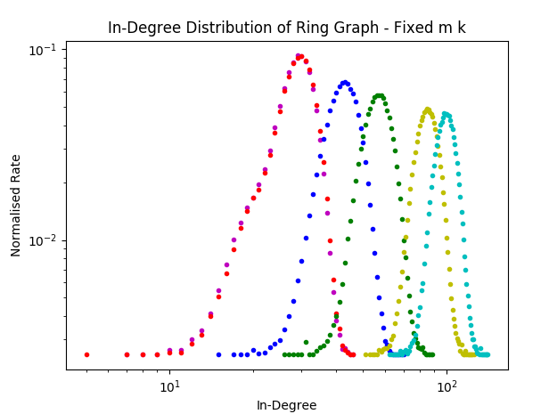

m = k = 20

Red: p = 0.49999

Purple: p = 0.499

Blue: p = 0.45

Green: p = 0.4

Yellow: p = 0.3

Cyan: p = 0.26

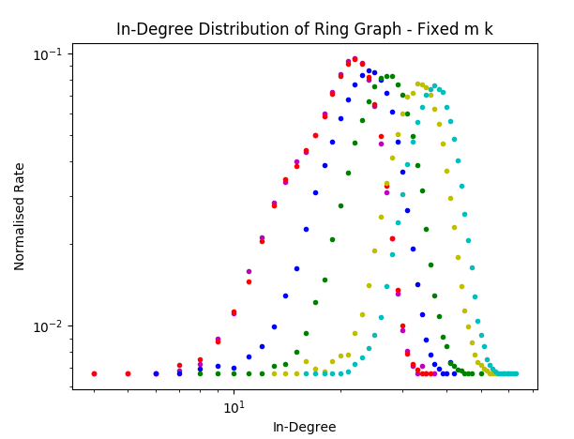

m = 10, k = 15

Red: p = 0.49999

Purple: p = 0.499

Blue: p = 0.45

Green: p = 0.4

Yellow: p = 0.3

Cyan: p = 0.26

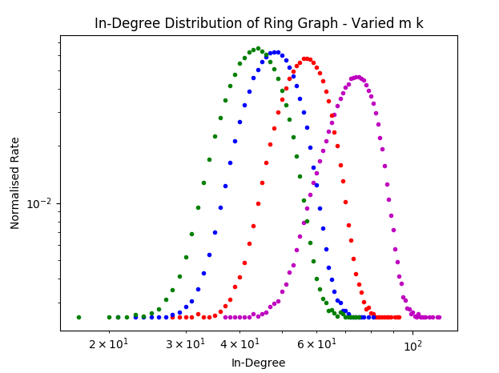

p = 0.4, q = 0.1

Green: m = 10, k = 40

Blue: m = 20, k = 20

Red: m = 40, k = 10

Purple: m = 80, k = 5

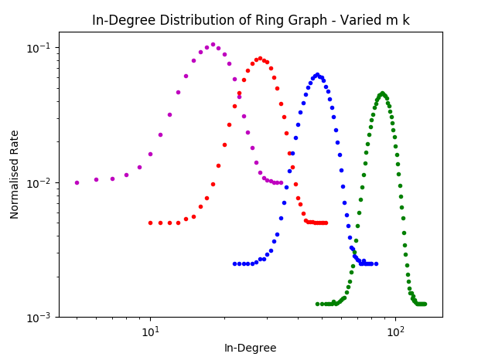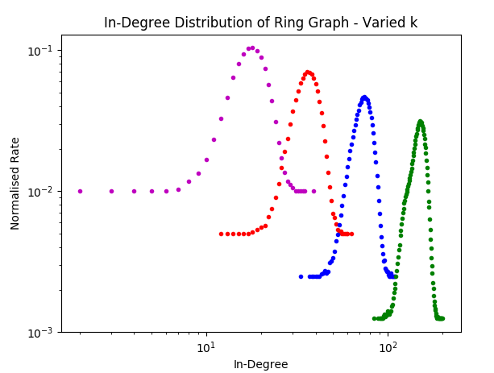

p = 0.4, q = 0.1

Purple: m = 10, k = 10

Red: m = 10, k = 20

Blue: m = 10, k = 40

Green: m = 10, k = 80